Dinner Menu Activity

Directions: Below you will see a list of tasks to choose from. Make sure you are doing what it says to do (i.e. do not do more than one entrée). Also, make sure you are following the directions as to how many you will do. Please complete these in your writer’s notebook.

Appetizer (Everyone shares – in other words, everyone completes this)

- Write the three types of third person point of view.

Entrée (Select One)

- Draw a picture of a situation using third person point of view.
- Write two paragraphs (at least ten sentences) about what each type of third person point of view means (third person objective, third person limited, and third person omniscient).
- Create a poem (at least ten lines) that explains third person point of view.

Side Dishes (Select at Least Two)

- Define and give an example in your own words of third person objective point of view.
- Compare the three types of third person point of view using a Venn diagram (see below for picture; the middle parts where circles overlap (cross each other) are the similarities).

Third person limited
Third person objective
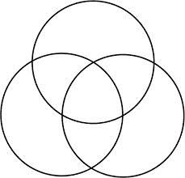
Third person omniscient

- Write at least a one page story that uses third person limited or omniscient points of view.
- Write a letter to someone you know about Ms. Engle using third person objective point of view.

Dessert (Optional)

- Make a poster (flyer) that informs others about the types of third person point of view (in your own words).

